

Practices for Secure Software Report

Table of Contents
Document Revision History 3
Client 3
Instructions 3
Developer 4
1. Algorithm Cipher 4
2. Certificate Generation 4
3. Deploy Cipher 4
4. Secure Communications 4
5. Secondary Testing 4
6. Functional Testing 4
7. Summary 4
8. Industry Standard Best Practices 4

Document Revision History

Version | Date | Author | Comments
1.0 | [18 August 2024] | [Ian Repsher]

Client



Instructions

Submit this completed practices for secure software report. Replace the bracketed text with the relevant information. You must document your process for writing secure communications and refactoring code that complies with software security testing protocols.

- Respond to the steps outlined below and include your findings.
- Respond using your own words. You may also choose to include images or supporting materials. If you include them, make certain to insert them in all the relevant locations in the document.
- Refer to the Project Two Guidelines and Rubric for more detailed instructions about each section of the template.

Developer
Ian Repsher

Algorithm Cipher

Recommendation: Advanced Encryption Standard (AES)
- Overview: AES is a symmetric encryption algorithm widely used for securing sensitive data. It operates on block sizes of 128 bits and can use key sizes of 128, 192, or 256 bits.
- Hash Functions and Bit Levels: AES uses block ciphers and hash functions like SHA-256 can be used in conjunction to ensure data integrity.
- Random Numbers & Key Types: AES uses symmetric keys, meaning the same key is used for encryption and decryption. Random number generators produce secure keys and initialization vectors (IVs) for encryption.
- History and Current State: AES was established by the U.S. National Institute of Standards and Technology (NIST) in 2001 and remains the global standard for encrypting data.

Certificate Generation
Insert a screenshot below of the CER file.

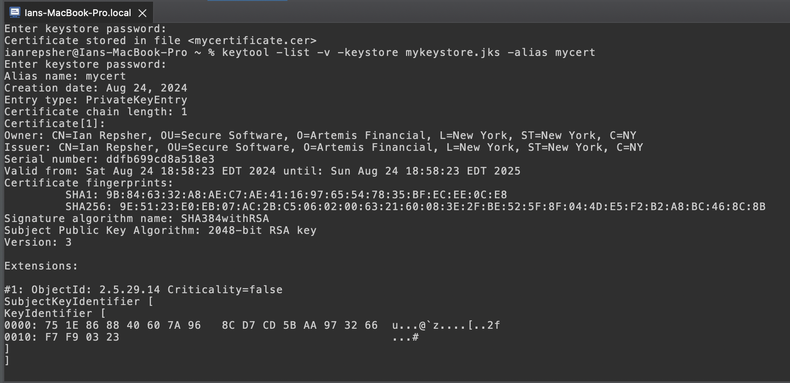

Deploy Cipher
Insert a screenshot below of the checksum verification.

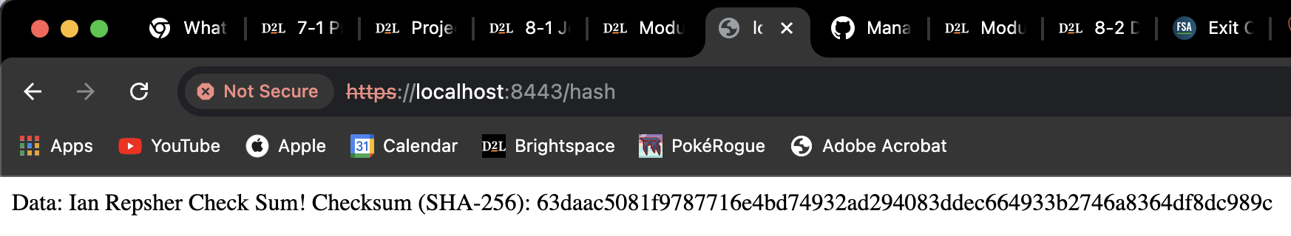

Secure Communications
Insert a screenshot below of the web browser that shows a secure webpage.

HTTPS is working, but my Cert isn’t official because it’s self-signed.
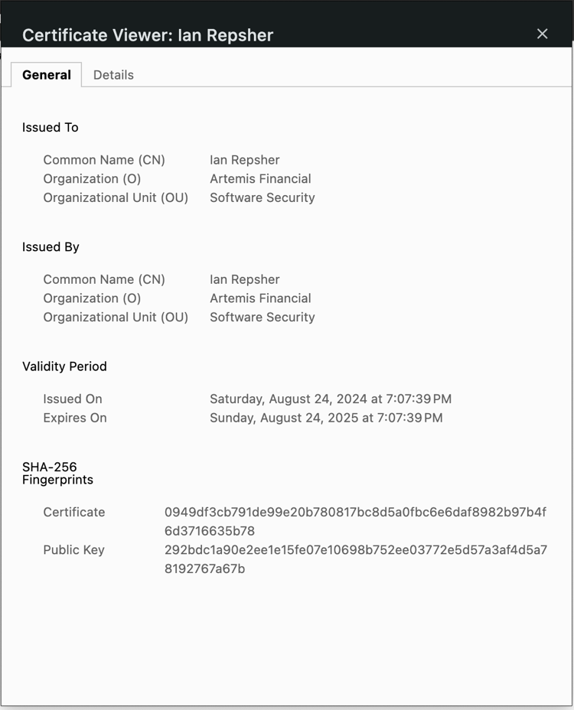

Secondary Testing
Insert screenshots below of the refactored code executed without errors and the dependency-check report.

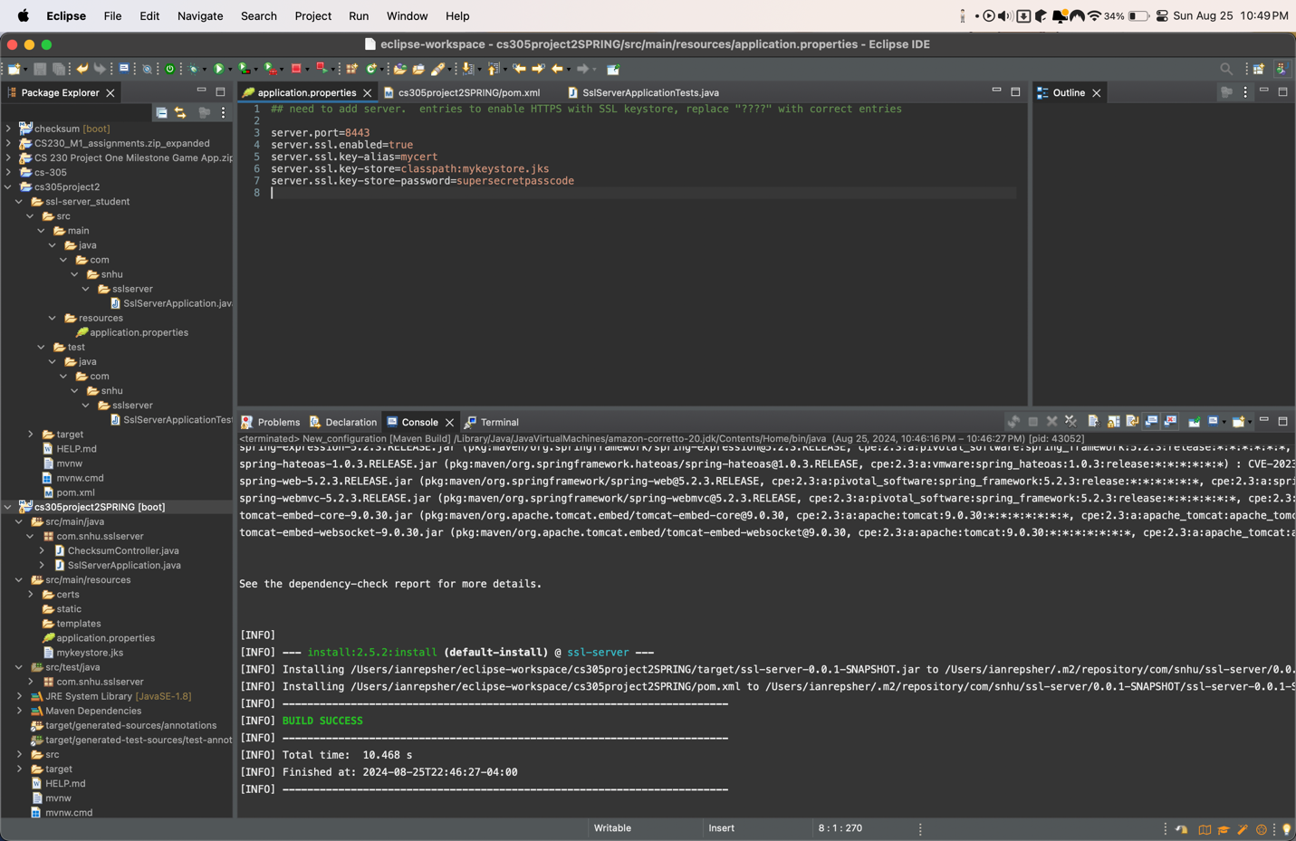
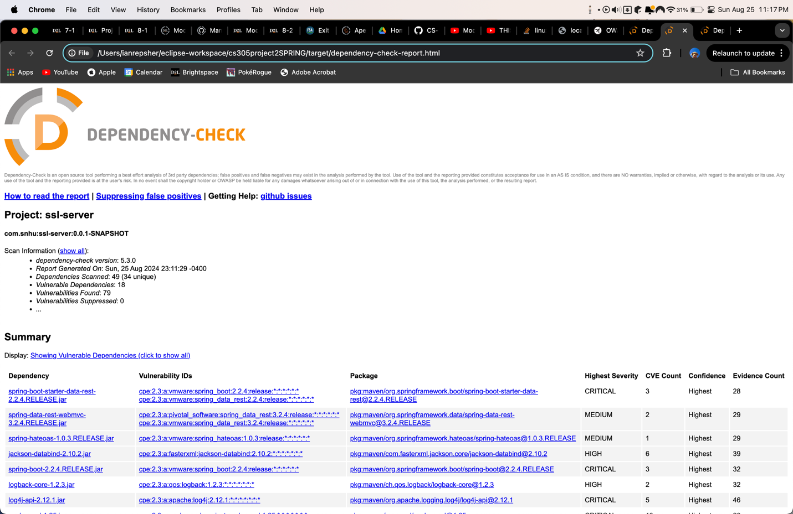

Functional Testing
Insert a screenshot below of the refactored code executed without errors.

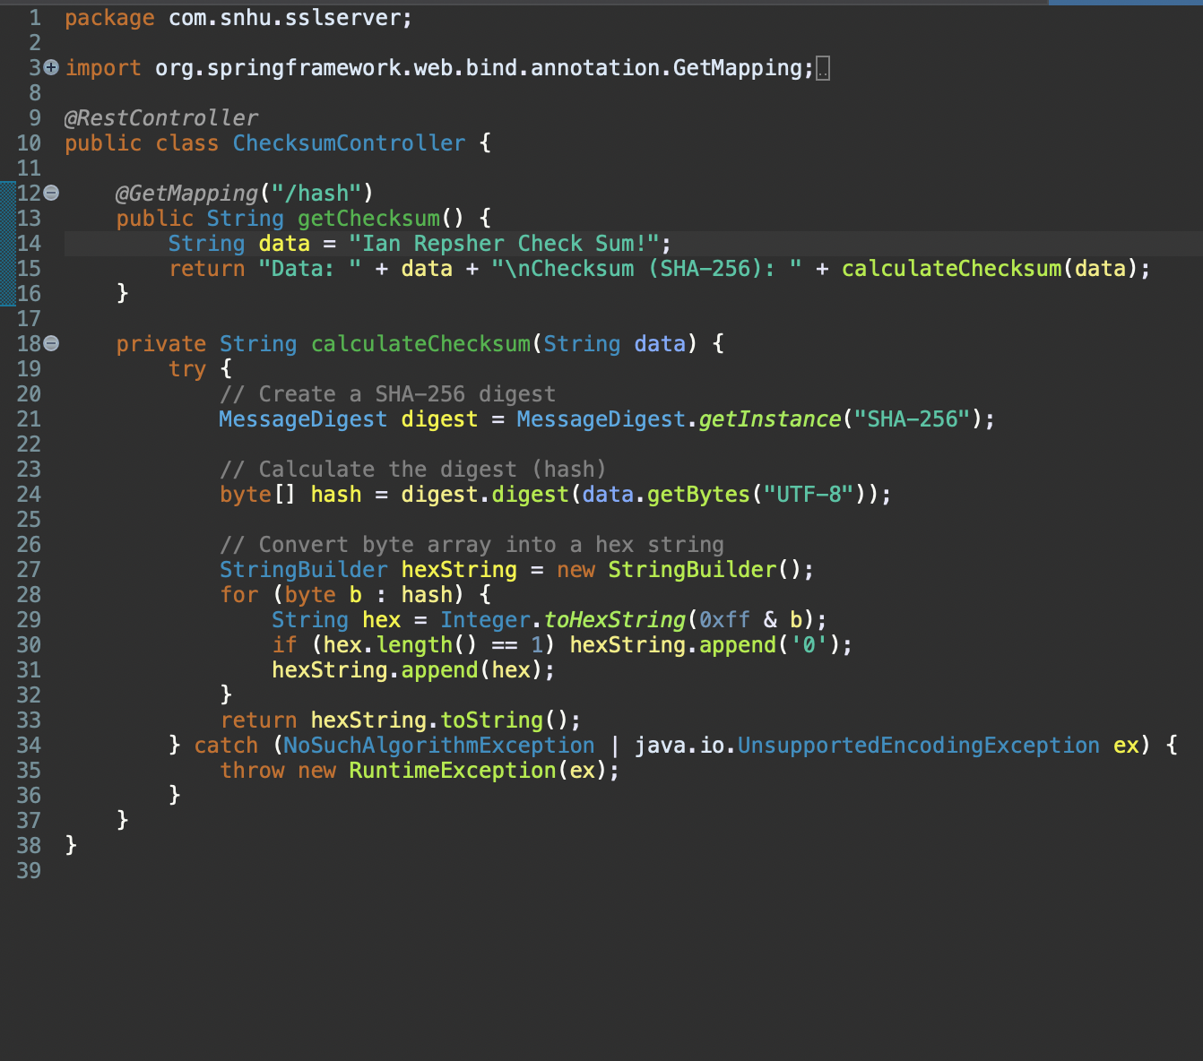

Summary

Refactoring & Security Compliance:
Vulnerability Assessment Process:

- The refactoring process involved securing the communication channels by enforcing HTTPS, adding checksum verification to ensure data integrity, and generating self-signed certificates for secure communication.
- The vulnerability assessment process involved conducting static and functional testing, ensuring that no new vulnerabilities were introduced during the refactoring.

The primary security layers added included:
- Encryption: Implementing AES encryption for secure data handling.
- Checksum Verification: Ensuring data integrity with SHA-256 checksum.
- Secure Communication: Enforcing HTTPS to secure client-server communication.

Industry Standard Best Practices

Maintaining Existing Security:
- By following best practices such as using strong encryption algorithms, regularly updating dependencies, and adhering to secure coding principles, the existing security of the application was maintained and enhanced.

Overall Value to the Company:
- Secure coding practices are crucial for protecting sensitive financial data. Implementing these practices makes the application more resilient to attacks, ensuring the safety of customer data and maintaining the company’s reputation.

Conclusion:

The refactoring process successfully integrated modern security protocols into the existing application. The combination of static and functional testing ensured that the application was secure and functional without introducing new vulnerabilities. This process shows the importance of secure coding practices in maintaining a company's overall well-being, particularly in industries handling sensitive information like finance.

